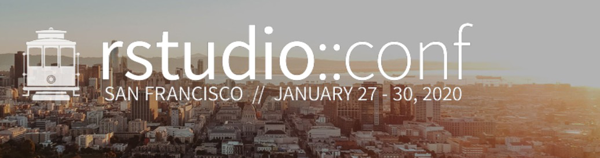

250 Northern Ave  
Boston, MA 02210

January 17, 2020

Dear workshop attendee:

Thank you for registering for R Markdown and Interactive Dashboards! Yihui and I are looking forward to sharing two fun-filled days of R Markdown and Interactive Dashboards with you, and we hope you are too.

We’d like to make the most of our time together in person, so we recommend spending a bit of time preparing for the workshop. You should already have received an email with general recommendations such as bringing your laptop and power cord (if you didn’t, [the document is here](https://docs.google.com/document/d/1_-uhk9dQt_LhpdUrmrCMgcznS79xyZ6EDQHrY1rhfhI/edit?usp=sharing)), so we’ll focus here on recommendations that are specific to R Markdown and Interactive Dashboards.

## **Prior to the beginning of the workshop on January 27**

This workshop is taught using rstudio.cloud, a cloud-based learning environment. That means that most of your work will be done online using a browser instead of in an IDE on your laptop. With that said, you’ll be able to get started more quickly on the first day of the workshop if you:

* **Bring your tablet or mobile phone in addition to your laptop.**
* **Create an account on rstudio.cloud.** All you need to create an account on rstudio.cloud is to visit <https://rstudio.cloud>, enter a valid email address, and hit “Sign up”. Alternatively you can log in with an existing Google or Github account.
* **Download R software onto your laptop as a backup.** While this step isn’t strictly necessary, should rstudio.cloud go down during the class, you’ll want to be able to continue with the course using a local version of R.
  + A recent version of R (>=3.6.0), which is available for free at <https://cloud.r-project.org/>
  + A recent version of RStudio Desktop (>=1.2), available for free ([RStudio Desktop Open Source License](https://www.rstudio.com/products/rstudio/download/#download))
  + A modern browser. Supported browsers include:
    - Microsoft Edge
    - Internet Explorer 11+
    - Chrome
    - Safari
    - Firefox
  + The following R packages. You can do this all at once by typing: install.packages(c("geonames", "tidyverse", "magrittr", "rmarkdown", "flexdashboard", "leaflet", "babynames", "tufte", "rticles", "shiny", "DT", "reticulate", "revealjs", "plotly")
    - geonames
    - tidyverse
    - magrittr
    - rmarkdown
    - flexdashboard
    - leaflet
    - babynames
    - tufte
    - rticles
    - shiny
    - DT
    - reticulate
    - revealjs
    - plotly

## 

## 

## **On Monday, January 27, the day your workshop begins**

Our workshop will be held in the **Continental Ballroom Rooms 7-9** on the Ballroom level of the Hilton Union Square Hotel. **The workshop will begin promptly at 9 am**.

* **Get registered in the Yosemite Room, Ballroom Level.** Getting more than 1,300 people registered and badged is going to take time. You can avoid waiting in long lines by arriving early, getting some coffee, and finding the room. Registration starts at 6:30 am. Better yet, if you are local to San Francisco, come register on Sunday night between 4 and 7 pm.
* **Find a seat and power in Continental Ballroom Rooms 7-9 on the same level as Yosemite.** You will need your conference badge to gain admission to the workshop in
* **Check to make sure you can get to rstudio.cloud.** While we’ll provide power and Internet, you’ll need to bring your laptop and power cord to your workshop session. Don’t forget that if you signed up for day care when you registered, you can drop off your children at our private day care service beginning at 8 am and can pick them up before 6 pm.
* **Plan for two full days.** Workshops will begin at 9 am and end by 5 pm and are structured as 4 90-minute sessions each day. Lunch will be provided from 12:30 to 1:30, and half-hour breaks will be at 10:30 and 3:30.
* **Wear layers.** We’ll do our best to keep the workshop rooms comfortable, but we know that no matter what temperature is set, some will find the room temperatures too hot or too cold. We recommend wearing light clothes in case the room is warm and bringing a sweater or jacket in case it is too cold.

## **Join the community after your workshop**

Learning doesn’t end when the workshops finish. Open bar receptions between 5:30 and 7:30 on both Monday and Tuesday evenings will give you a chance to talk about what you’ve learned in a less formal environment and to network with instructors and students from other workshops.

We look forward to seeing you in San Francisco!

Carl Howe, Director of Education  
Rstudio